Assignment - Data Transform Activity (20%)

- a) Create a new table for your analysis called “employee_sales”.
- Load the table “employee” into this table.
c) Select these columns: Attrition, Department, JobSatisfaction & MonthlyIncome.
Query:
CREATE TABLE employee_sales AS
SELECT Attrition, Department, JobSatisfaction, MonthlyIncome
FROM employee;

2) Round the data found in the “MonthlyIncome” column to the nearest $1000. (HINT: the SQL function to round a number is ROUND(obs, -3))

Round MonthlyIncome
Query:
SELECT Attrition, Department, JobSatisfaction,
ROUND(MonthlyIncome, -3) AS MonthlyIncomeRounded
FROM employee_sales;
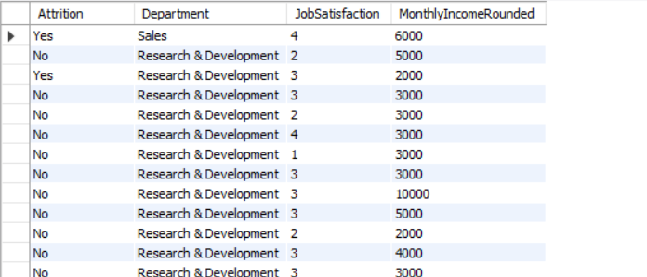

3) Filter the data to only look at those items in the “Sales Department”.

Query:
SELECT Attrition, Department, JobSatisfaction,
ROUND(MonthlyIncome, -3) AS MonthlyIncomeRounded
FROM employee_sales
WHERE Department = 'Sales';
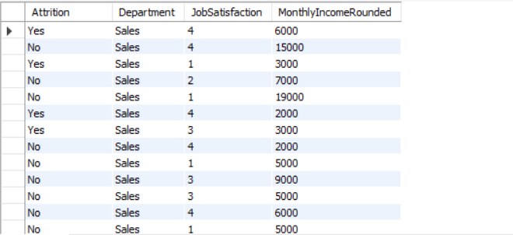

4) Order the data by “JobSatisfaction” from highest to lowest. (HINT: Use the DESC query)
Query:
SELECT Attrition, Department, JobSatisfaction,
ROUND(MonthlyIncome, -3) AS MonthlyIncomeRounded
FROM employee_sales
WHERE Department = 'Sales'
ORDER BY JobSatisfaction DESC;
